**Introduction to Artificial Intelligence and Machine Learning**

**Introduction to Artificial Intelligence and Machine Learning**

We will begin to introduce to you both artificial intelligence and machine learning. In this overview, we will discuss how to properly define what the precise definitions are for artificial intelligence, machine learning, and deep learning, and how to differentiate between the three. One hint I want you to know off the bat is that deep learning will be a subset of machine learning, which in turn will be a subset of artificial intelligence.

To understand the depth of where artificial intelligence has brought us in recent history, two of the biggest breakthroughs which we will continue to touch on as we go through the history of artificial intelligence are an **image processing** and **machine translation**.

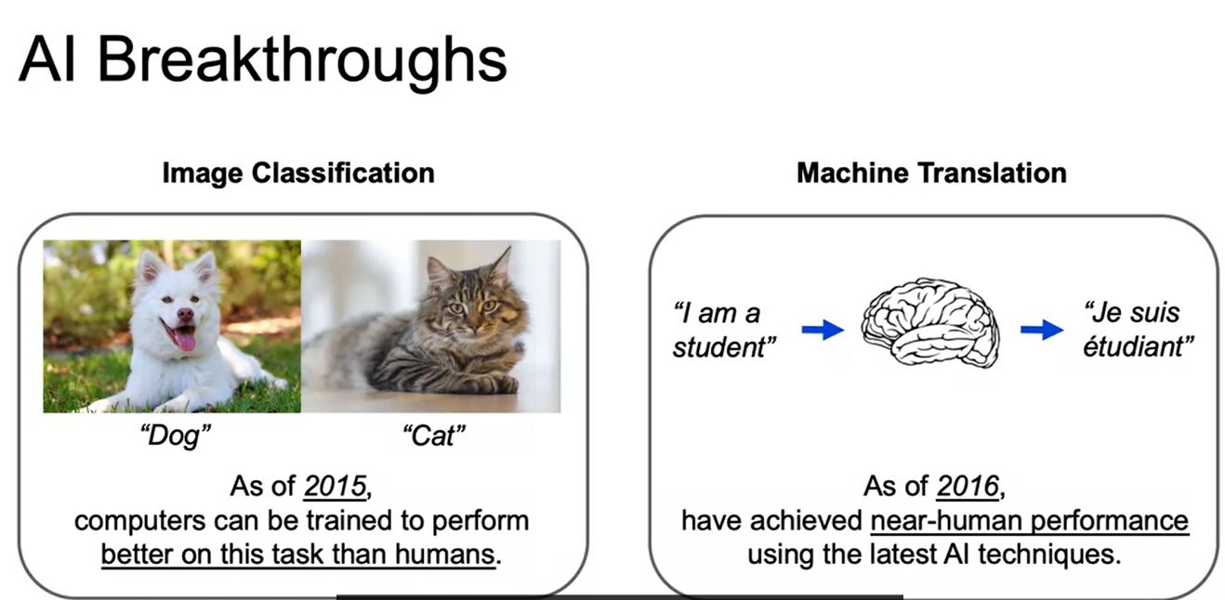

To understand the **image classification**, imagine we are given this task to identify which one of these pictures is a dog and then which one of these pictures is a cat. And going back to 2015, computers have been able to do a better job of classifying such images into categories than humans. For **machine translation**, our goal is to take a phrase or sentence in one language, such as I am a student. And then give the translation in another language, keeping in mind all the intricacies of word ordering and proper phrasing of that other language, which we have here in French. And incredible work is being done so that machines can translate to near-human performance. Now, these are very tough problems for classical machine learning models. For images, it was hard to identify useful features. And then for natural language processing, translations are, as we discussed, not as simple as just going word by word. But keeping into account the word ordering, and the proper phrasing, and the common use within different languages. Now, advancements in deep learning, as well as innovations in the realms of data storage and processing power, have given us this ability to step up and start to have this capability to now push past these machine learning models, these classic machine learning model barriers.

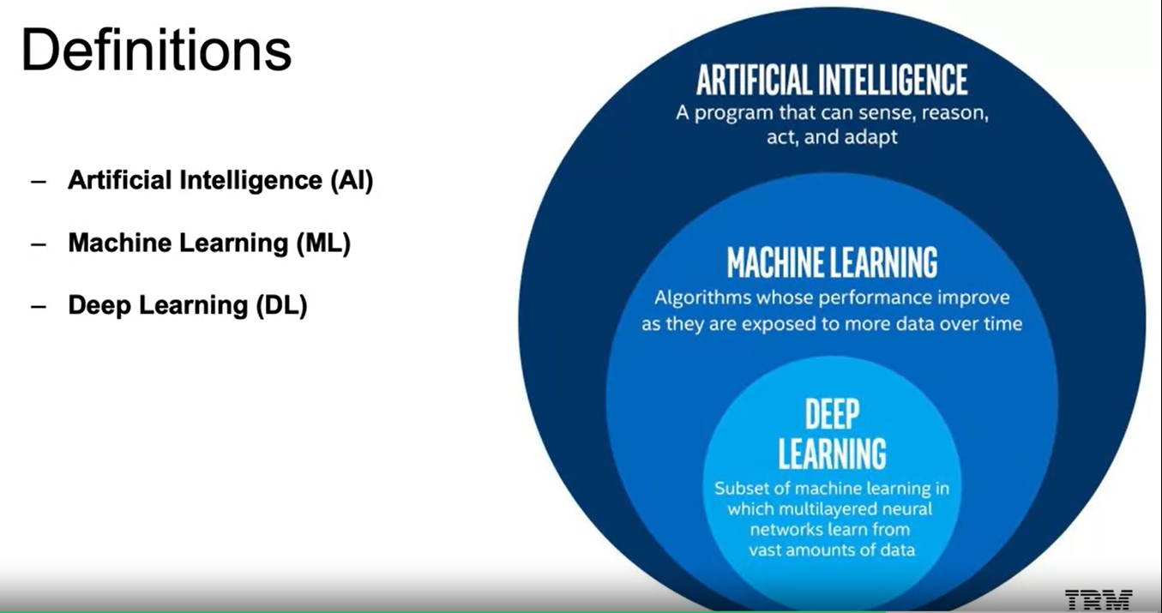

**Deep learning** is a subset of **machine learning**, and machine learning, a subset of **artificial intelligence**. If we look at the definitions, we have written out here, we see that:

* **Artificial intelligence** is any program that can sense, reason, and act and adapt. It is essentially a machine taking any form of intelligent behavior.
* **Machine learning** is a subset of that, where it's able to replicate intelligent behavior, but the machine will learn as more data is exposed to it.
* **Deep learning** is a subset of machine learning. Meaning it will also improve as it's exposed to more data, but now specifically to those algorithms which have multi-layered neural networks.

Merriam-Webster Dictionary defines artificial intelligence as a branch of computer science dealing with the simulation of intelligent behavior in computers. So very similar to what we just mentioned, any means of simulating intelligent behavior. According to Wikipedia: “colloquially, the term artificial intelligence is applied when a machine mimics cognitive functions that humans associate with other human minds, such as learning and problem solving”. When we use the term artificial intelligence in our day-to-day, we see a very similar definition to what we have here and the idea that intelligence is defined as human intelligence. This has its roots in the historical coining of the term artificial intelligence and ties to the Turing question, which we'll discuss as we dive into the history of artificial intelligence. Just to make clear what would be an example of artificial intelligence that doesn't necessarily fall under our subsets of machine learning and deep learning. That would be something like a rule-based system where it doesn't learn as more data comes in.

**Machine Learning and Deep Learning**

Machine Learning is the study and construction of programs that are not explicitly programmed, but rather learn patterns as they're exposed to more data over time. Machine Learning is going to be a subset of Artificial Intelligence. It's going to be a subset that's going to learn from observing data. The more data, the better the algorithm can learn the underlying patterns.

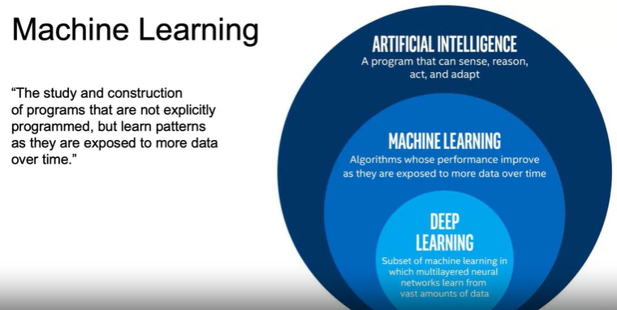

In general, the idea is going to be that as we gain more data, Machine Learning is going to be able to better understand the underlying patterns. So, these programs learn from repeatedly seeing data rather than being explicitly programmed by humans. So, it's not going to be a set of rules programmed by humans to make a decision.

As an example, let's say we're working with trying to decide whether emails are spam or not spam. We would start off with a dataset where we have a bunch of emails that are going to be labeled spam versus not spam. These emails will be preprocessed and fed through a Machine Learning algorithm that learns the patterns for spam versus not spam, and the more emails it has to learn the underlying patterns the better the model is going to get. Once the machine algorithm is trained, we can then use it to predict as new emails are coming in. So, we trained on this label dataset, and now we can run in production and as new emails come in, we can predict spam versus not spam.

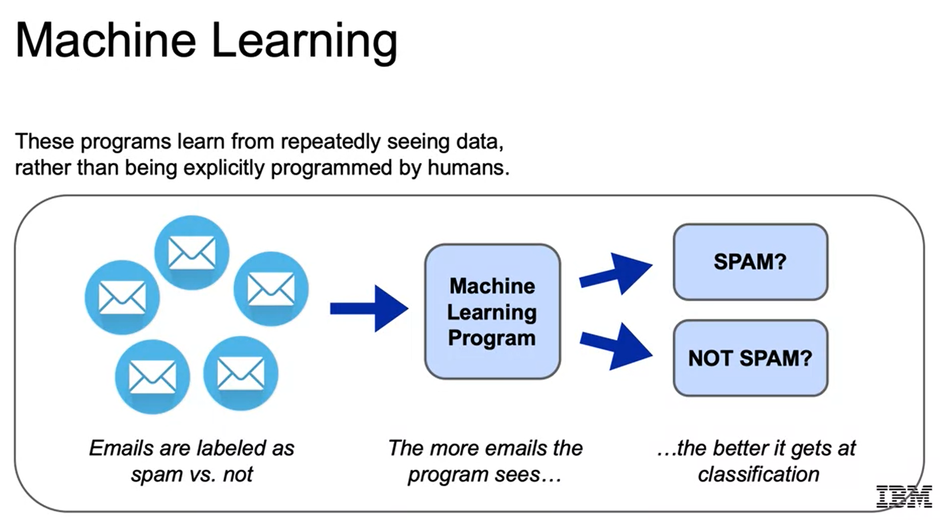

Now we're going to use a simple dataset just to highlight what **features** are and what a **target** is. Features and target are going to be important terms for us to understand. The iris dataset is a popular dataset often used to introduce basic concepts in Machine Learning. So, the iris here is going to be a flower that comes in three species as you see here: virginica, setosa, and versicolor, and **that's going to be the target that we're trying to predict**. So, our dataset here contains **four features**: *sepal length and sepal width, petal length and petal width*. Those are going to be the features we will use to make our prediction. Then again as I mentioned before, the target variable is going to be the column that we're trying to predict. The idea is to use the four features, sepal length, sepal width, petal length, and petal width in order to predict the species and then moving forward if we had those four features, we would be able to predict the species without the label.

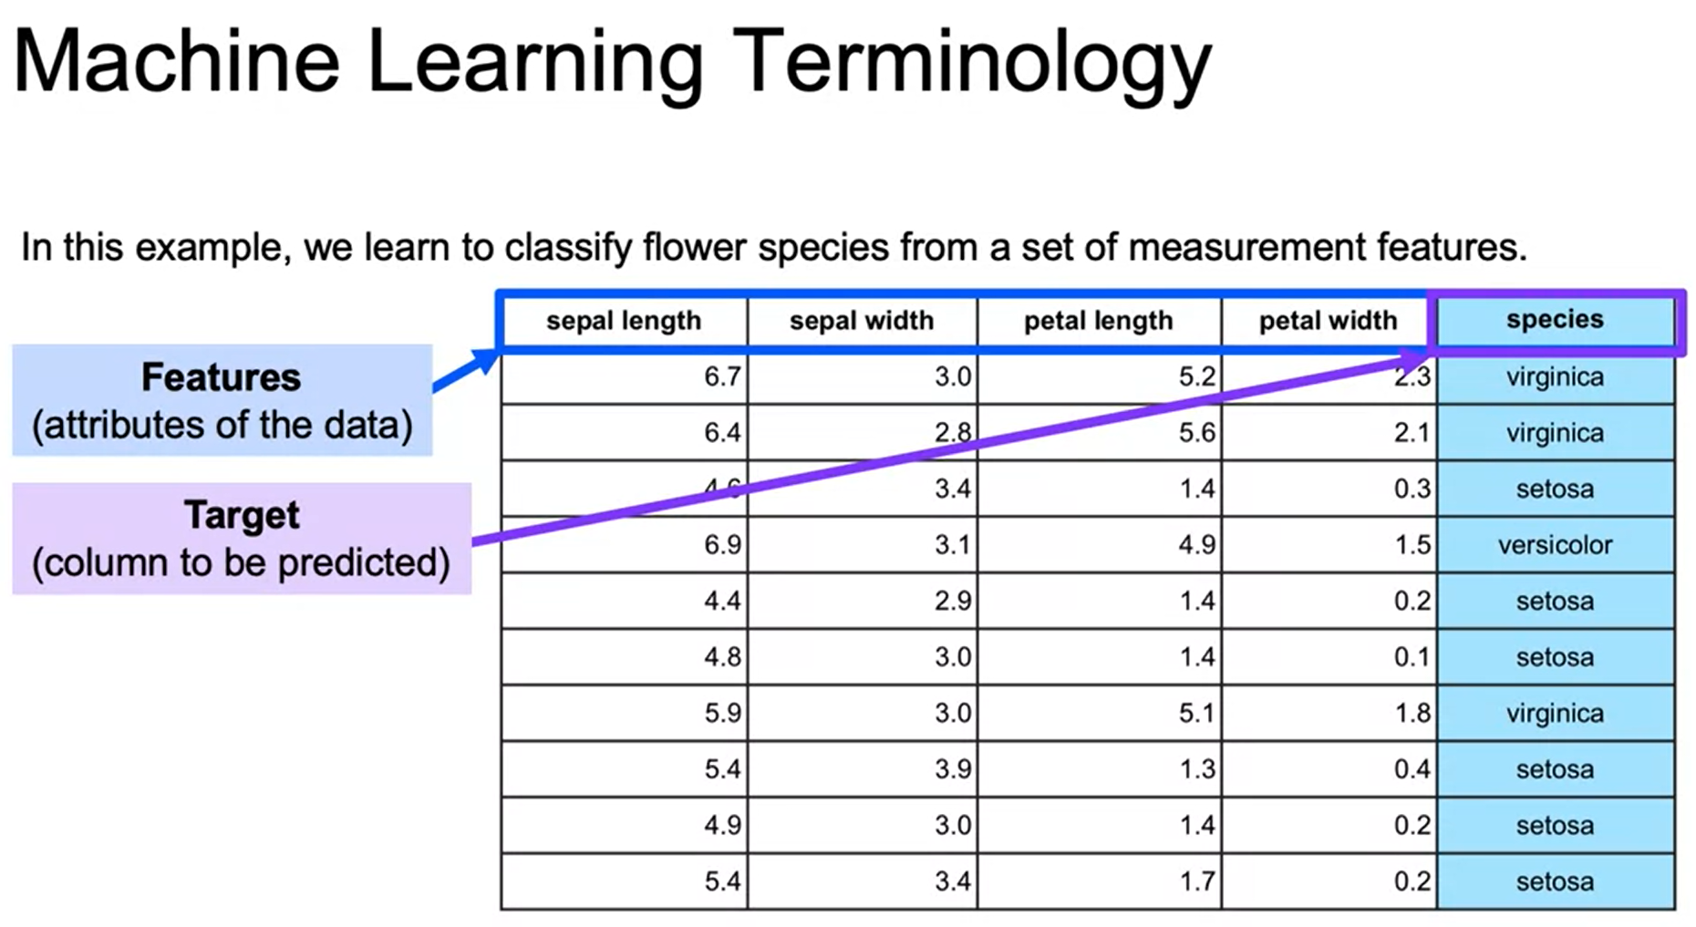

In general, there are two types of Machine Learning. There are **supervised learning** and **unsupervised learning**. For supervised learning, we will have a target column or labels like what we just saw with the email spam and iris flower classification examples, and then for unsupervised learning on the other hand we will not have a target column.

The goal for supervised learning is going to be able to predict that label. Is it spam or is it not spam? Is it's versicolor or another one of the different flower species? For unsupervised learning, the goal is going to be to find an underlying structure of the dataset without any labels, and this will be clear with our examples. An example of supervised learning is fraud detection. We may have a large dataset where we have labels of either this transaction is fraud, and this transaction is not fraud. We would learn from all the features related to fraud detection and be able to predict as new credit card transactions come in whether those are fraud or not fraud. For unsupervised learning, an example would be customer segmentation. For this, you can think about customer segmentation to find similar groupings within your dataset for a marketing campaign, you have this e-commerce data, and you want to separate them out into groups in order to target them accordingly. For unsupervised learning, there's going to be no right or wrong answer. So, the user will need to test different models and see which results tend to make the most sense.

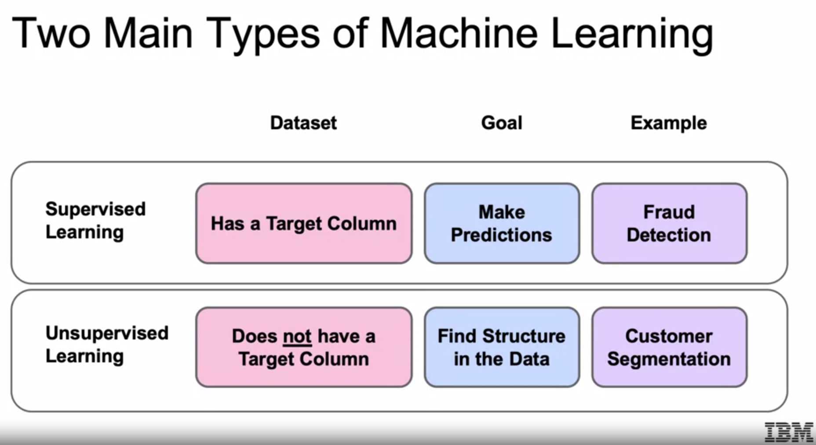

Suppose you wanted to identify fraudulent credit card transactions, detecting fraud is going to be a common Machine Learning problem. You can define your features to be transaction time, transaction amounts, transaction location, category of purchase. Combining all these features together, we should be able to predict in the future with transaction time, the amount location in the category of purchase, whether there's unusual activity, and whether this transaction is fraud versus not fraud. This structured data with intuitive features are going to be a good task for our traditional Machine Learning.

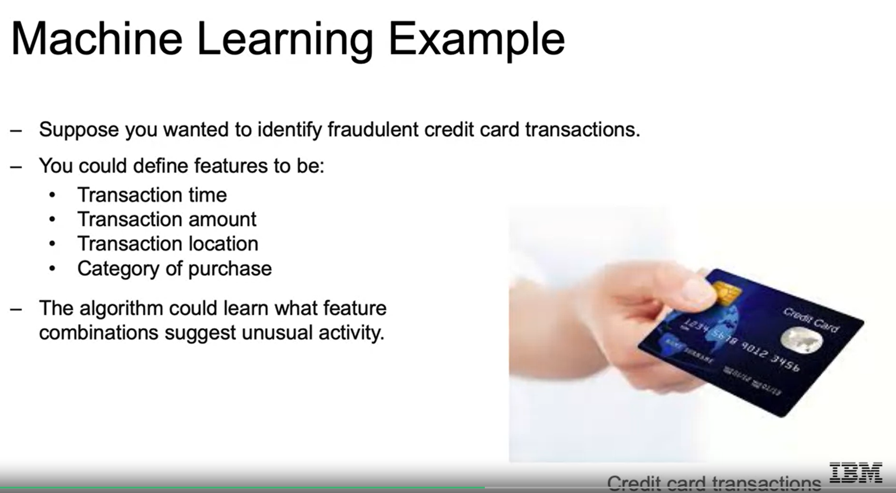

Now, defining features in an image, on the other hand, is a much more difficult and involved task and has been a defining issue of the limitations of our Traditional Machine Learning techniques that Deep Learning has now done a good job of addressing. So, suppose you want to determine if an image is a cat or a dog, so what features should we use? For images, the data is taken as numerical data to reference the coloring of each individual pixel within our image. A pixel then could be used as a feature. So, we saw the features before in our dataset. But if you imagine even a small image will have 256 by 256 pixels, which will come out to over 65,000 pixels. Sixty-five thousand pixels mean 65,000 features which is a huge number of features to be working with. Another issue is that using each pixel as an individual, you lose the spatial relationship to the pixels around it. In other words, the information of a pixel makes sense relative to its surrounding pixels. So, you have the different pixels that make up the nose perhaps, or the different pixels that make up the eyes, and then separating that out according to where they are in relation to the face, so on and so forth. This is where Deep Learning can come in. Deep Learning techniques will give you the capability to learn these features on its own and combine these pixels to define these spatial relationships.

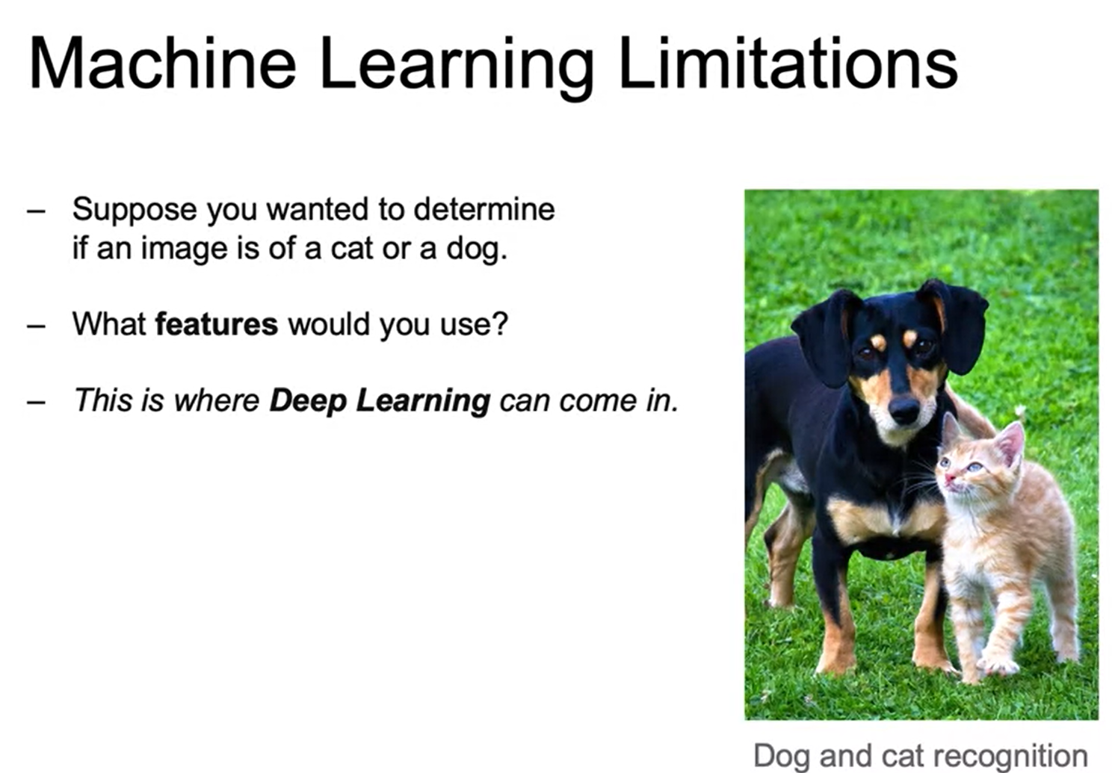

Deep learning is going to be Machine Learning that involves using very complicated models called deep neural networks. The models themselves will be able to determine the best representation of our original data. In classic Machine Learning, humans must come up with these features and this will allow us to solve complex problems such as what we just saw with the image classification. Deep Learning is the cutting edge and is where most of Machine Learning research is focused as blown away the performance of other algorithms when you're dealing with larger datasets. But it is very important to note that you'll often be working with smaller datasets, and standard Machine Learning algorithms will often perform significantly better than working with Deep Learning techniques. Also, if the data is changing a lot over time and you don't have a steady dataset, again Machine Learning will probably do a better job of being able to have better performance over time.

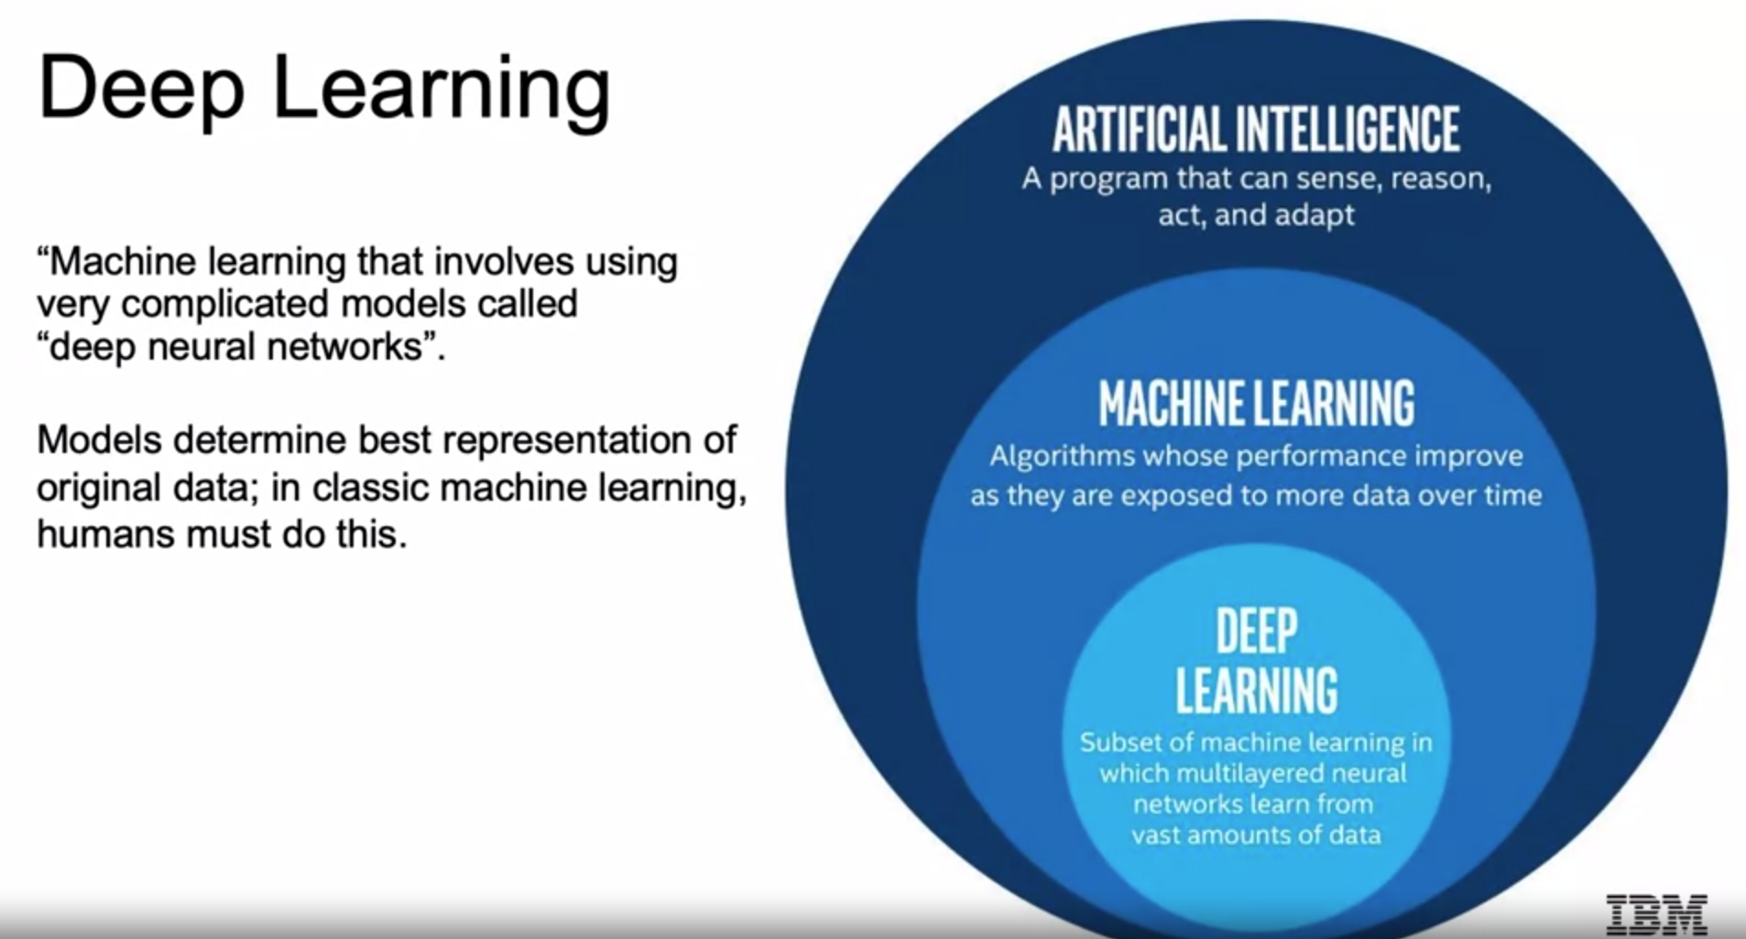

In the Classical Machine Learning model, we are going to have to define these features ourselves a priority before we feed the data to our actual model, so determining the features that make up the nose, the eyes, so on and so forth. We can then use the features and include them in a Machine Learning algorithm. If a data scientist is lucky, he may be able to guess good features, but this is a really challenging to do well. Then they can use that to predict that this is a picture of Arjun. Now Deep Learning will combine this two-step process. The neural network receives these pixels of an image as an input. The neural network learns how to extract these features that are meaningful from the image by combining them together in different complex combinations. Now, these features may not always make much sense when we try to interpret them in these intermediate layers. But ideally, they will first highlight edges and then combine those edges to make up shapes like nose, eyes, lips. But whether the intermediate steps are interpretable, they can be very useful for completing tasks such as image classification and coming up with the intermediate feature engineering steps, and then eventually predicting Arjun.

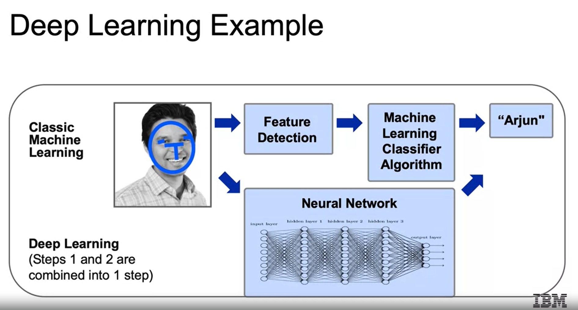

**History of AI**

AI has gone through several cycles where there have been both significant amounts of investments and excitement, as well as large walls in these investments as well as the excitement.

So, going from earlier algorithms and the initial excitement, as the term artificial intelligence was officially coined, and the first investments and promise began to be discussed on a larger scale in the 1950s. We then in the 1960s and 1970s, hail our first AI Winter, as the old failed to live up to the promise of the initial expectations. Then in the 1980s, AI got its second boom as businesses found it possible to utilize rule-based algorithms, called expert systems to aid in decision-making. Along with that, many theoretical breakthroughs introduce the promise behind neural networks. But then as promised, we had another AI Winter. In the late 80s and into the 90s, another failure to be able to leverage the promise of the expert systems and neural networks, and practical applications led to another decrease in investments. Then in the late 90s and early 2000s, machine learning proved to be successful in many tasks, such as speech recognition, Google's search algorithm and many others. And then finally, fast-forwarding to today, there were major breakthroughs in deep learning proving to be able to overcome many of the historical practical limitations of the initial neural networks. And they began to outperform classical machine learning techniques in many complex big data problems, such as image classification and machine translation. So, we see this up and down, and then finally hear this excitement around deep learning as they able to accomplish all these tasks that were once set with such high bar when we first started to think about artificial intelligence.

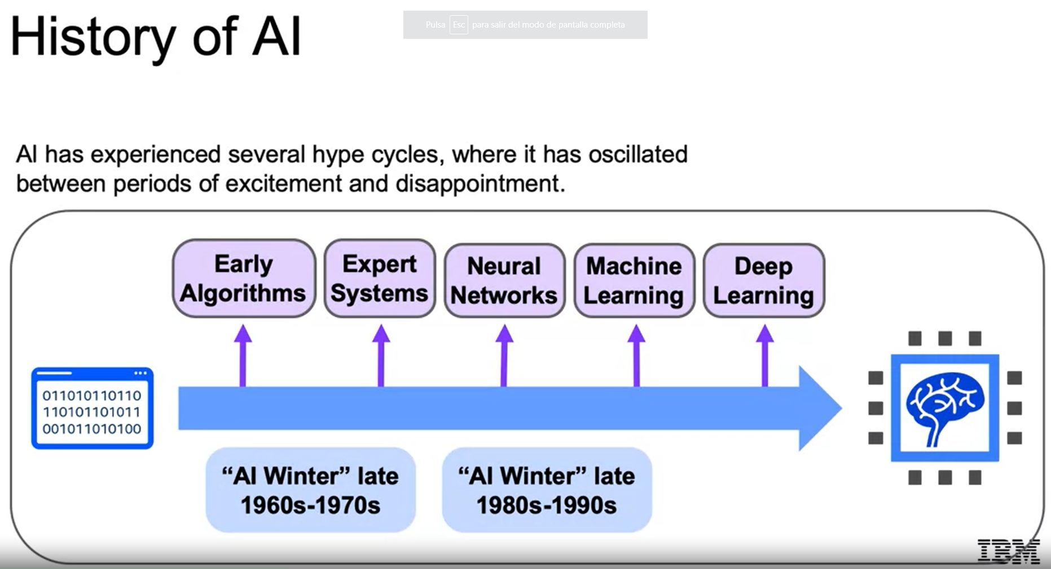

Let's go all the way back to the beginning. In 1950, Alan Turing developed the Turing test to test a machine's ability to exhibit intelligent behavior. Alan Turing's test has served as a foundational threshold for artificial intelligence. The idea being, will a computer ever be able to sufficiently imitate a human to the point where a suspicious judge cannot tell the difference between human and machine? In 1956, Artificial Intelligence was accepted as a field at the Dartmouth Conference. With this conference, researchers from various fields excitedly agreed that artificial intelligence, that is the simulation of intelligent behavior in computers, was indeed achievable. In 1957, Frank Rosenblatt invented the perceptron algorithm, which is the precursor to our modern neural networks. And it generated a ton of excitement in the field, as it showed how one can come up with a model that learned from data fed into the machine. And then in 1959, Arthur Samuel published an algorithm for checkers program, which was intelligently built according to the limitations of computation at the time obviously, to learn from the current state of the board and the positions at seen in the past to come up with the next move.

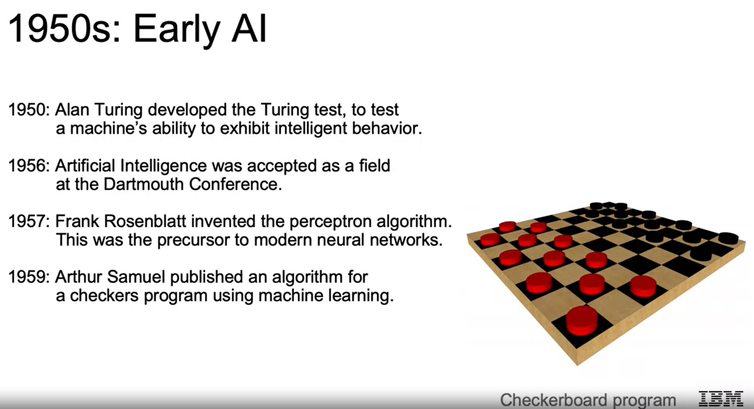

As promised following this excitement, we face our first AI Winter. During the Cold War, machine translation, specifically between Russian and English, was one of the major goals in artificial intelligence. In 1966, a committee was formed of seven scientists, put in place by the US government, specifically to assess the progress of machine translation. And this group deemed there was very little return on investment, dealing a major blow to the hype around artificial intelligence. Then in 1969, Marvin Minsky's work identified major limitations to Rosenblatt's perceptron algorithm, dealing yet another blow to artificial intelligence. In 1973, the highly regarded British applied mathematician, James Light hill published a report highlighting how discoveries and research have fallen well short of the high hopes laid out over the past few decades, leading to government's cutting back much of their funding in artificial intelligence research.

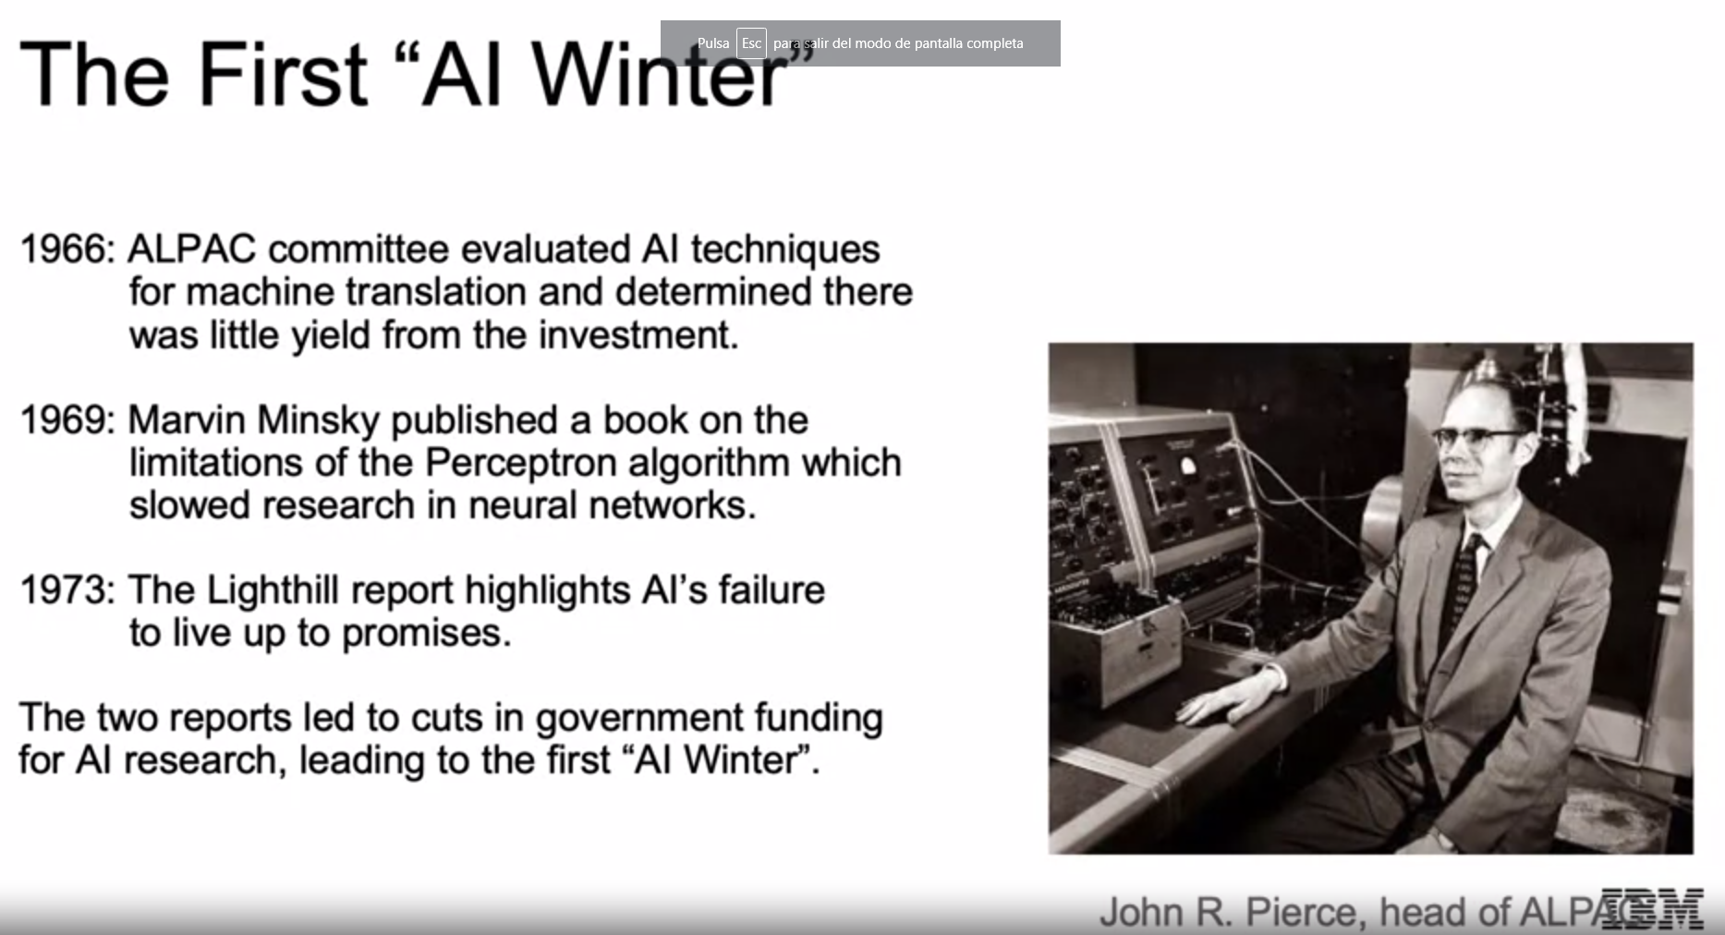

Then as discuss, we have our winter, then we have our next boom. In the 1980s, expert systems became all the rage. These systems were built with programmed rules designed to mimic human experts, the idea being too hard code the machines with facts and rules representing expert knowledge of different subjects. These programs ran on powerful mainframe computers using specialized programming languages, such as LISP, which is one of the oldest high-level languages and was the most popular for artificial intelligence research at its time. These expert systems gained huge popularity. And AI infiltrated the business world at a large scale for the first time here in the 1980s. And then on another note, another significant event in the history of AI during this time, was Geoffrey Hinton and others published works explaining the Backpropagation algorithm, possibly, the most important algorithm for deep learning, which allowed for multi-layer networks to better update its parameters using the data given. This drove a huge excitement in the fact that researchers could now theoretically learn complex multi-layer models that can actually learn from new data.

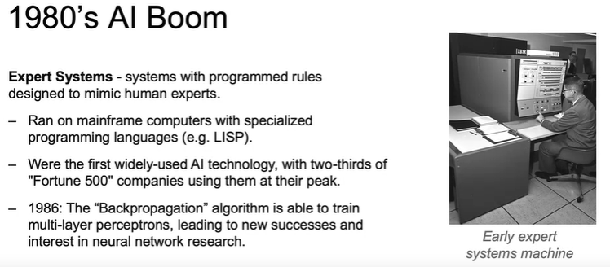

And then we hit our next AI Winter in the 80s and 90s. Expert systems' progress on solving business problems slowed, major reasons being their inability to learn, also they were finicky. They could make terrible mistakes when they received abnormal inputs. Expert systems began to be melded into software suites of general business applications that could run on PCs instead of mainframes. So, the investment in large mainframe computer subsided, as much of their capabilities were incorporated into these regular desktops. Neural networks didn't scale to large problems. The Backpropagation algorithm that generates so much excitement faced many problems with implementation of problems with large data sets and large networks. And then with these in mind, the excitement behind utilizing artificial intelligence for business once again subsided.

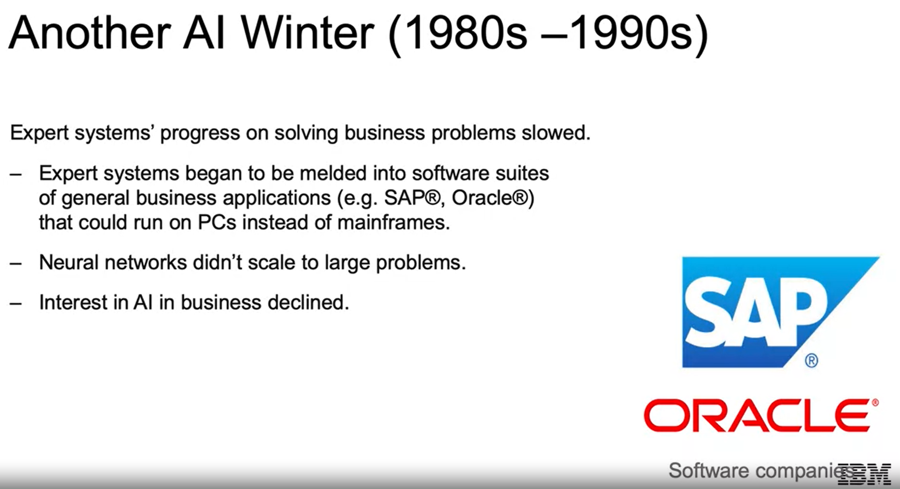

**History of Machine Learning and Deep Learning**

We're in the 90s and 2000s, and AI solutions using classical machine learning techniques began to take off. AI solutions had successes in speech recognition, medical diagnosis, robotics, and many other areas. AI algorithms were integrated into larger systems and once again, became useful throughout industry. In 1996, Deep Blue accomplished the major feat of being the first machine to defeat a world champion chess player. So, you can imagine the hype and excitement as a machine is able to beat a human in chess for the first time. Also, Google revolutionized the search engine space with its PageRank algorithm to display search results.

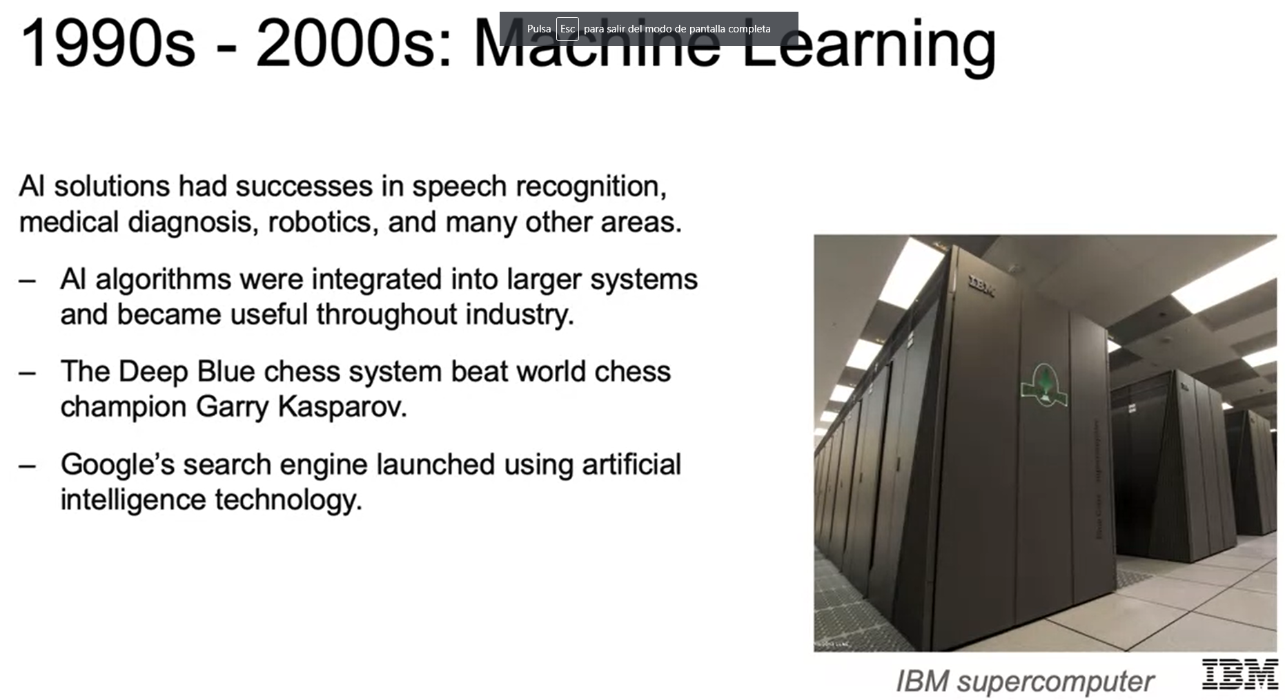

In 2006, the previous limitations of deep learning, namely exploding and vanishing gradients, which we'll touch on later in the course, were overcome with algorithmic advancements such as Geoffrey Hinton's work on unsupervised pre-training. Neural networks are rebranded as deep learning, as we can train much deeper networks, networks with more layers. In 2009, the ImageNet database was introduced, which was a groundbreaking data set that provided millions and millions of labeled images, which were not available before, today to practitioners. Then in 2010, algorithms compete on several visual recognition tasks at the first ImageNet competition. This greatly increased the opportunity for an algorithm to try and learn from many examples, the complexities of the patterns that make up a cat or a dog, or even a certain breed of dog.

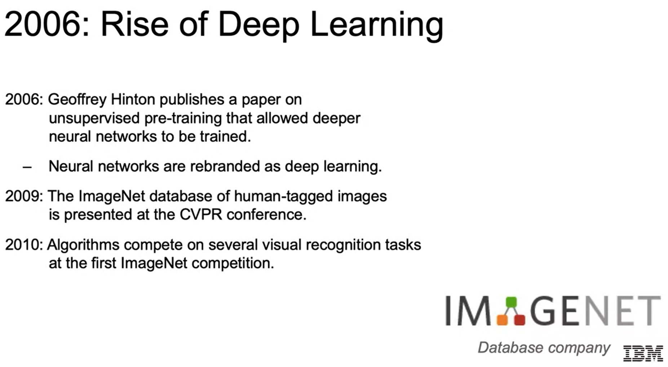

In 2012, a deep learning model using convolutional neural nets called AlexNet achieved a top five error of 15.3 percent, blowing out the competition that was more than 10.8 percent points lower than the next lowest error. So, from there, the practical applications for deep learning began to take off. In 2013, it was used to give description of the conceptual meaning of words by learning from copious amounts of written data. In 2014, we saw similar breakthroughs in the task of machine translation, leveraging concepts such as recurrent neural nets, making what was once one of the major goals in the 60s, if you recall that was one of the causes of the first AI winters, an actual reality. These have led to advancements in web search, document search, document summarization, and machine translation.

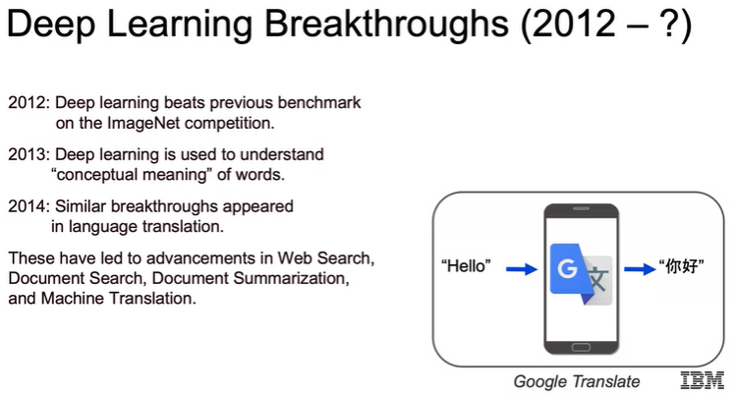

In 2014, Stanford researchers elevated computer vision to another level with the ability to annotate photos with captions such as baseball player throwing a ball in game, rather than just saying this is a human, it's able to give a bit of a story behind an actual picture. In 2015, one of the most popular libraries, TensorFlow, was built for deep learning, making it more powerful and accessible. In 2019, this was made even more accessible while gaining even more flexibility and power as well, with version 2.0 incorporating the high-level libraries Keras, which we'll touch on later. In 2016, DeepMind's AlphaGo was able to defeat a Go master, a game considered much more difficult than chess due to the prohibitively large number of possibilities for every single move. In 2018, Waymo, the self-driving car taxi service launched by Google, began giving rides in the suburbs of Phoenix. In 2019, the IBM Project Debater put on a fascinating debate with a champion human debater, showing the ability to argue a topic, listen to a human response, and then give a rebuttal accordingly. Those are just some of the many major highlights of where we are today with artificial intelligence.

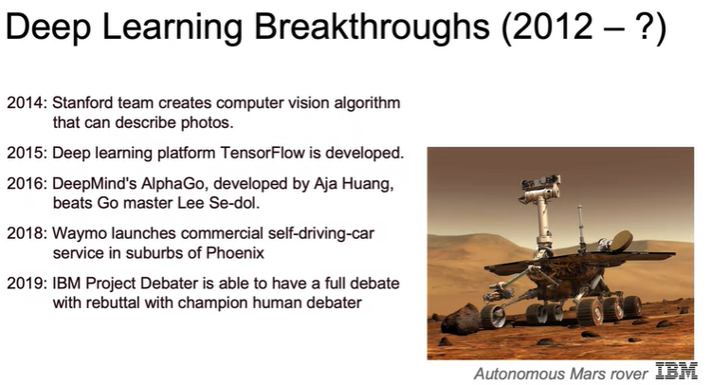

**Modern AI: Applications and the Machine Learning Workflow**

**Modern AI**

So where are we today? Two spaces where seeing drastic growth and innovation are computer vision and natural language processing. The sharp advancements in computer vision are impacting multiple areas. Some of the most notable are cars getting to the point where they can drive themselves. In healthcare, computer vision is now used to review different imaging modalities, such as x-rays and MRIs to diagnose illnesses. We're fast approaching the point where machines are doing as well, if not better than the medical experts. Similarly, natural language processing is booming with a vast improvement in ability to translate, determine sentiment, clustering of new articles, writing papers, and many others.

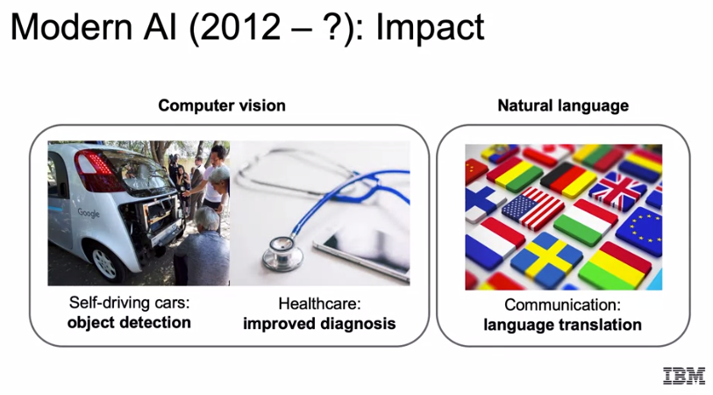

Does this era of AI different? Main factors are bigger datasets. We now have larger and more diverse datasets than ever before. We talked about how ImageNet and how that was able to open the opportunities to train models that need larger datasets to learn complex patterns. With the Cloud infrastructure now in place to store copious amounts of data for much cheaper, and the plethora of new ways to capture data are now able to build larger, more new once datasets to learn underlying patterns across a multitude of fields. We have faster computers. We now have access to powerful hardware for processing and storing data. The mainframe computers used to first drive the expert systems in the '80s costs about $200,000 a month. We can now get stronger and faster computers that sit on our laps. Neural networks have finally taken off in the past decade and proven to be successful. We have had constant innovation in the area of deep learning leading to practical results within the industry. All this is leading to cutting edge results in a variety of fields. So, we can think about with our phones, how we're able to use our face to unlock our phones, how they recognize our voice, how it's able to look at pictures and identify pictures of us or our friends. We have stores where we can walk in and pick things up such as Amazon Go and not have to go to a checkout counter. We have our homes being powered by our voice telling it we want music played or for the lights to be switched on or off. All of this has been driven by this current era in artificial intelligence.

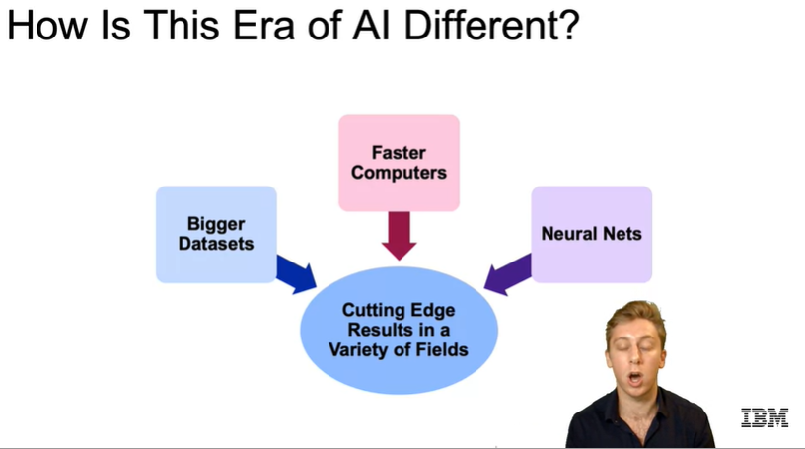

Within healthcare, as discussed, AI is now used to aid in medical imaging. Often computers can diagnose as accurately or even more accurately than medical professionals. For drug discovery, a great example is Pfizer has turned to IBM Watson to leverage machine learning to power its drug discovery and search for immuno-oncology drugs. Patient care is being driven by AI, as well as AI research within the healthcare industry and has helped advance sensory aids for the deaf, blind, and those that have lost limbs. In industrial, we can now automate factory work for efficiency and lower costs. We can monitor for future system failures and schedule maintenance in advance, able to enhance and optimize agricultural production. Field automation can track our sales, inventory, and delivery needs at a much quicker pace.

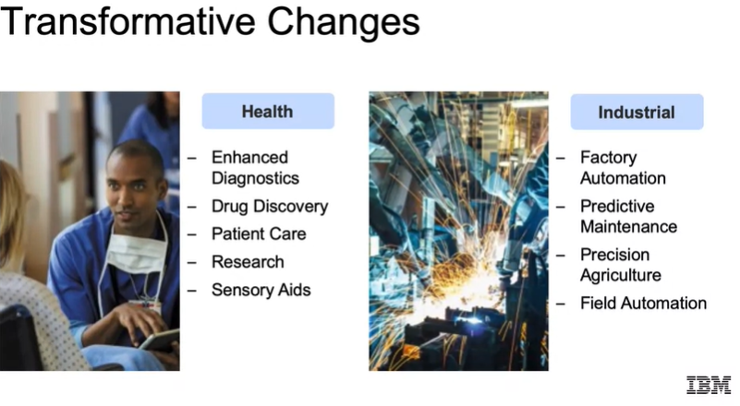

For finance, we have algorithmic trading, fraud detection, research, our personal finance, risk mitigation, all being driven by AI. For energy, it's being used to locate and extract oil and gas reserves. We have smart grids which essentially are meant to optimize electrical grid for more efficient infrastructure. We're also able to improve overall operations within the industry and we also are learning to conserve energy using artificial intelligence. Within government, defense and identifying threats. Think about our cold war example and where we are today. Gaining insights for all major issues, whether they are threats from weather or pandemics, or simply gaining a better understanding of their citizen’s needs. We have a driving safety and security as they have more access to data from both abroad and at home. It's able to enhance their engagement between government and citizens. It's aided in building smarter cities to optimize things such as traffic, healthcare, police and fire protection, and the distribution of energy. Transportation, we have autonomous cars, automated trucking for deliveries. AI is huge in aerospace to optimize simulations, maintenance, and prototyping. It's able to come up with optimal routes and timing for shipping. AI has helped in the search and rescue fields with drones now being built up machine learning algorithms to help search and detect missing people in areas that may be too dangerous to initially explore by humans, and so much more. We have personalized advertisements, personalized education, able to identify what a student does and does not know and develop a personalized curriculum accordingly. Gaming can leverage many of the latest advances in AI to make a more human-like experience for players. Service industries are quickly able to automate many of their responses and reduce time and manpower needed to solve many common issues. For telco and media, we can think to how media is using AI to help consumers define the content that directly matches their interests. In sports, advanced analytics are driving the ways in which general managers recruit players, as well as optimizing ticket pricing and the other business operations. So, we see the extent to which AI is infiltrating all industries and why this era of AI is different than any other.

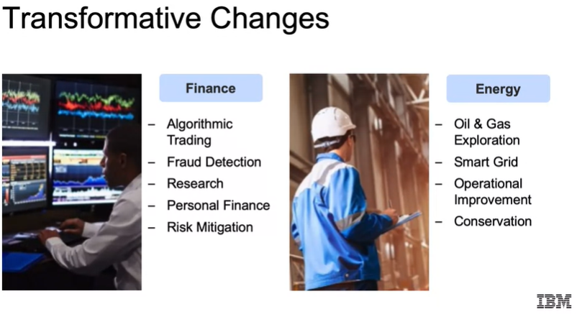 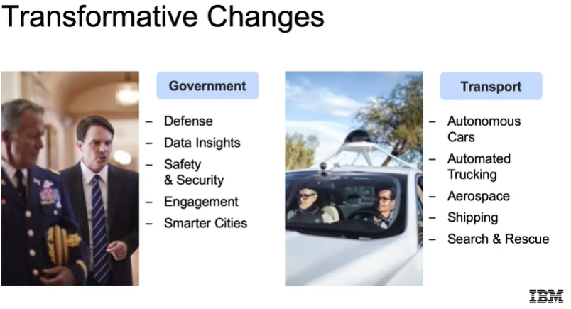

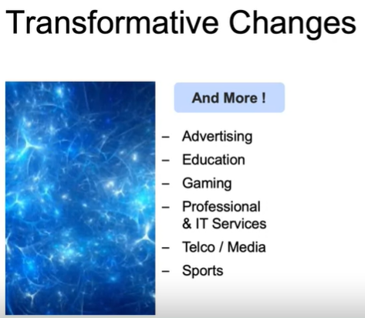

**Applications**

Let's think about artificial intelligence regarding our personal transportation. So, figuring out the shortest distance between two points is a classic problem since before the introduction of artificial intelligence. And today, we also add the complexity of knowing traffic information or predicting it based on historical data and weather conditions, so on and so forth. Google and Waze have been able to incorporate all these factors to constantly improve their algorithm for fastest means of getting from point A to point B. For ridesharing, Uber and Lyft can price their rides according to supply and demand, instead of a flat rate. And the supply and demand can be updated in real-time using artificial intelligence techniques.

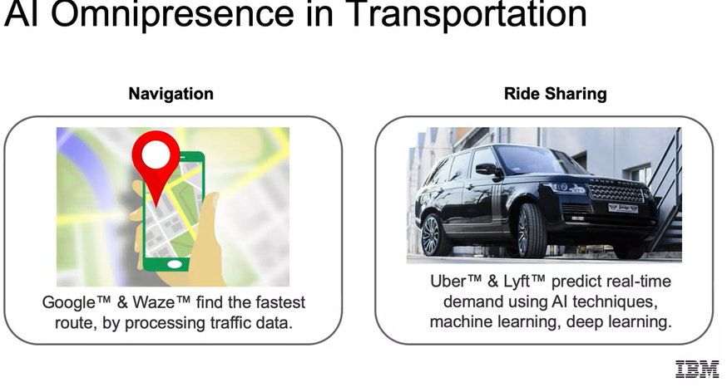

Social networking is one of the newest businesses that is exploring artificial intelligence. Artificial intelligence can now identify content relevant to an individual, recommendations for people or groups to connect with targeted advertisement delivery. We also see image recognition and sentiment analysis to ensure that the content is appropriate mood that we want to be served. Artificial intelligence has been successful at identifying the sentiment of content, such as the review of a restaurant. Is that a positive or negative sentiment?

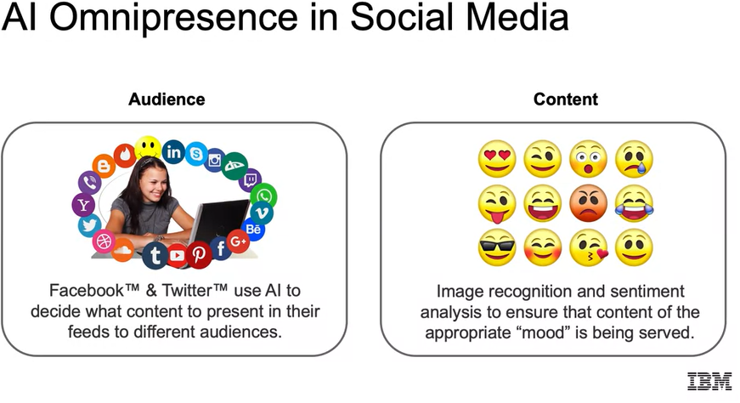

We have in our daily life. We think about natural language processing. Today, we have products, like Siri on our phones or Alexa in our homes that can recognize our voice and answer questions or do tasks for us. With object detection, this is important for self-driving cars. Facebook can recognize faces and pictures and suggest who that person is so photos can be easily shared with friends.

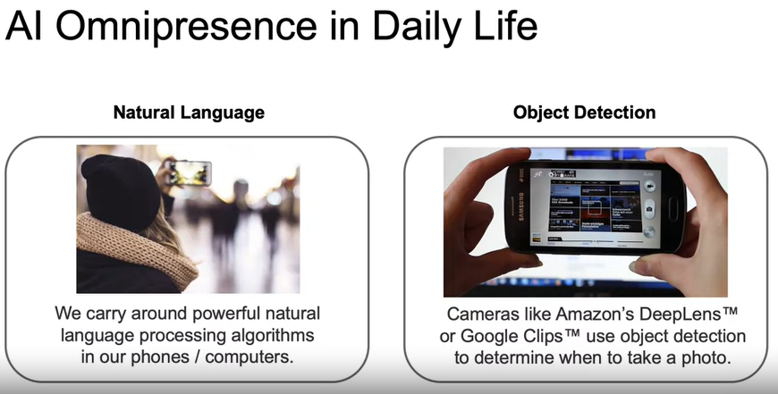

And with computer vision, when we talked about this pretty thoroughly throughout, we saw how deep learning is proven to work for image classification, able to outperform humans and many image classification tasks. And today, we see it doing live detection, which is going to be very important as we try to roll out self-driving cars.

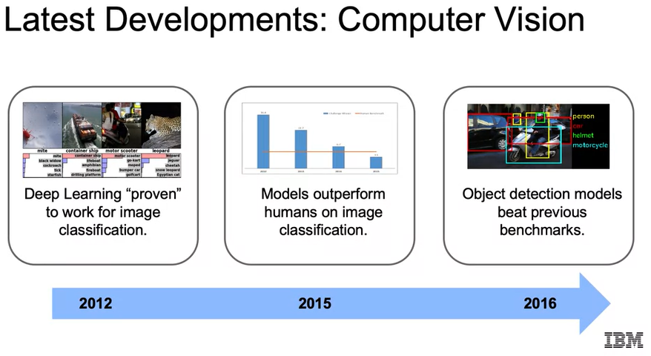

And moving into the future, how we can use this for things such as abandoned baggage detection. We can automatically detect when baggage has been left unattended, and this can potentially save lives. And this system is going to rely on cutting-edge object detection ran in real time. So, we see how this can actually be applied in real time using artificial intelligence.

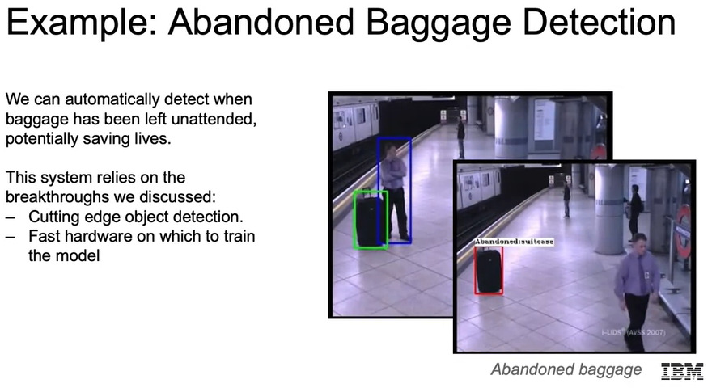

**Machine Learning Workflow**

In this course, we're going to assume familiarity with Python libraries, for example, NumPy or Pandas, working with Jupyter Notebooks. We'll also assume familiarity with basic statistics including probability, calculating moments, and Bayes' rule. Our examples we'll use iPython generally using our Jupyter Notebooks. We'll be using the following libraries: Numpy for numerical analysis, Pandas for which we're going to read in our data into Pandas Dataframes, Matplotlib and Seaborn for visualization, Scikit-Learn for machine learning, and then TensorFlow and Keras for deep-learning specifically.

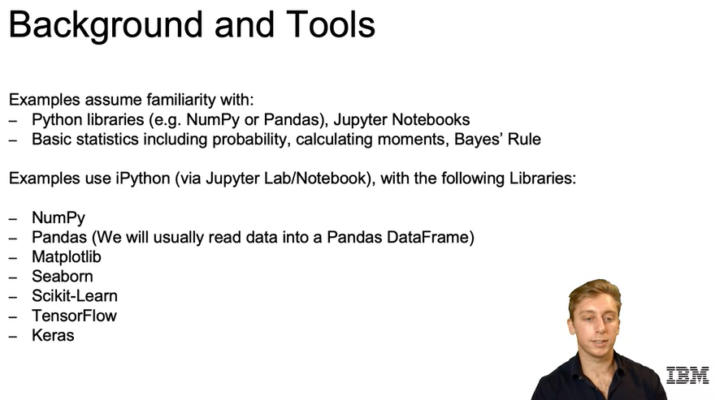

Let's dive into what our typical **machine learning workflow** will be. Our first step is going to be the **problem statement**. What problem are you trying to solve? I think with image recognition, it'll be the ability to classify different objects such as different breeds of dogs. Then it's going to be **data collection**. What data do you need to solve it? For the example we just posed, we would need more than a single picture of each breed but tons of labeled data for pictures in different lighting, from different angles that are all correctly labeled. Then we do our **data exploration and preprocessing**. How should you clean your data so your model can use it? So again, with the image classification example, we then want to dive into our data, look at the distribution counts, look at heatmaps of the densest points regarding our pixels. Also, for planning to use deep learning we will want to convert our pixels to multidimensional arrays given the scale for each color. Then we're going to go about actually **modeling**. So, we're going to want to build a model to solve our problem. We can try our model now. Probably start with some basic baseline model then we're going to **validate**. Did we solve the problem? We would check with the holdout set. So, we'd have a set of pictures that we haven't trained our model on and see how well we were able to classify that image given the labels that we have. Then comes **decision-making and deployment**. So, assuming that you did a good job in getting a certain range of accuracy, you would then move forward with communicating with stakeholders in regard to how to put this in production or actually just move forward and putting it into production.

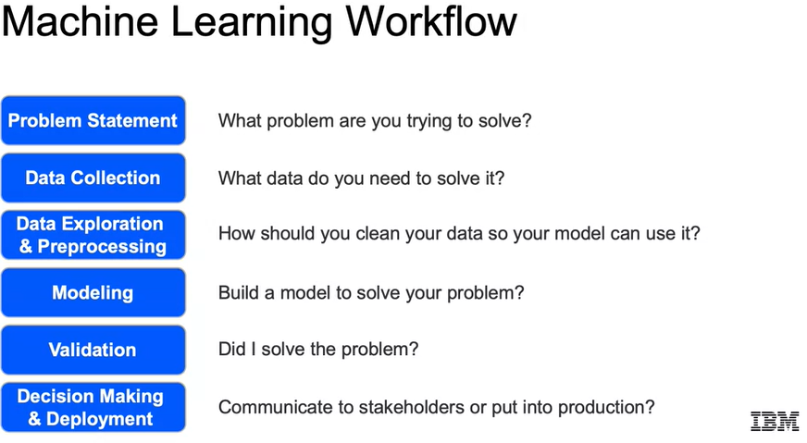

We'll start here with our **target** variable and that's going to be the target or value that we are trying to predict. Now it'll be easier to think of each of these vocabulary terms that we go over in the context of a spreadsheet. So here we're going to revisit the spreadsheet containing the well-known dataset on different iris flower species. We see here for each entry, the length, and the width for the sepal, as well as the length and the width of the petal and then we also have a label for which of the three species that entry belongs to. The idea being here that we'd be trying to predict later this species without having that available to us. So, the value that we're trying to predict, our target variable, which we just discussed would be the species in this example.

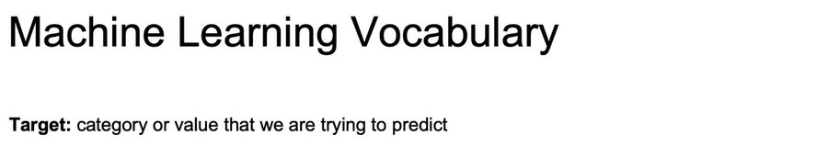

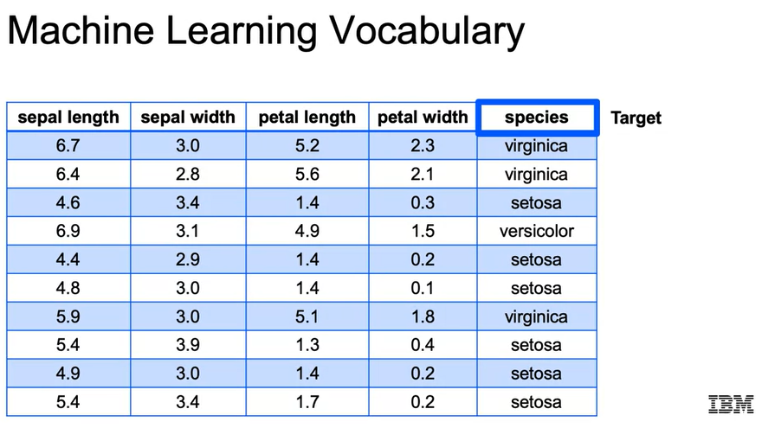

The next popular term that you'll want to be familiar with are your **features** or your **explanatory variables**. Those will be the other columns besides the target variable that you will use to predict your target variable. So later on, down the line when you're doing machine learning, when you don't have a label for your dataset, all you will have been the features. In the context of our spreadsheet, the features are going to be all the columns besides that target column. So for the iris dataset, there are four features, the sepal length, the sepal width, the petal length, and the petal width and those are going to be what are used in order to predict our target variable.

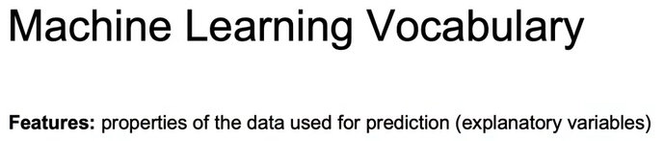

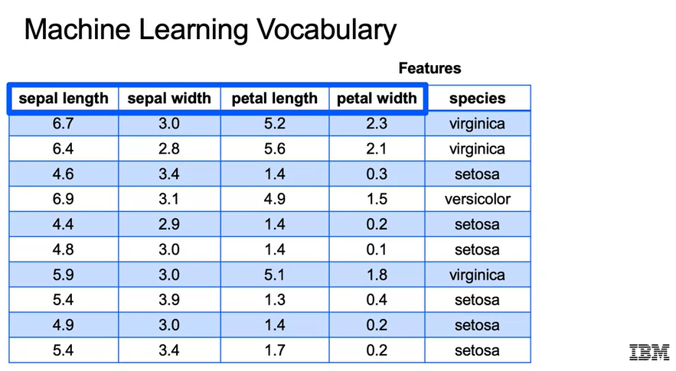

Another term that you're going to want to be familiar with is going to be an **example or an observation** and that's just going to refer to a single row within your dataset. So let's jump back into our iris dataset and think about what is an example within this spreadsheet. There are many examples in this iris dataset and all of them are used to try to train and optimize the right parameters for a Machine Learning model. So we see here one row, which is one example or another terms, one observation. You'll be hearing those terms interchangeably as you reference a single row.

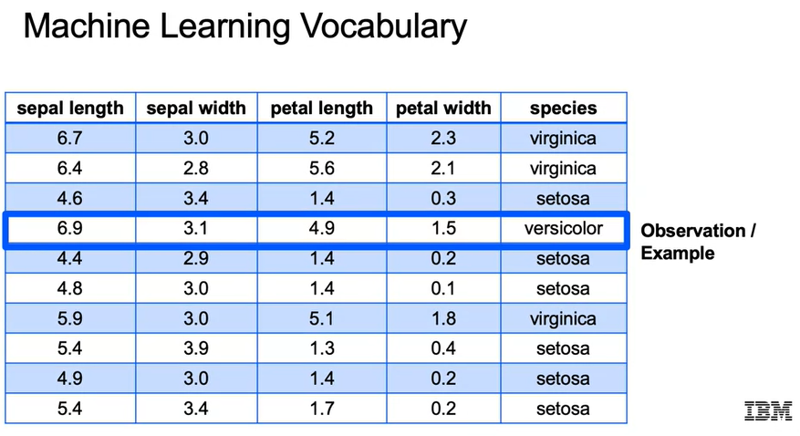

Now we introduce the **label**, and the label is just going to be **the value for your target variable**. So when we talked about an observation or an example, we're talking about the entire row. The label is just going to be just that one data point that refers to your target variable. For a label within our dataset, all that is a single example of our target variables. So here, versicolor would be an example of just a single label within our target variables.

